**Tehreem ijaz**

**Pf lab 2**

**Write a complete C++ program that produces the following output:**

**Hint: “Use “endl“ for newline“ Example : cout<< “all text in it ”<< endl”**

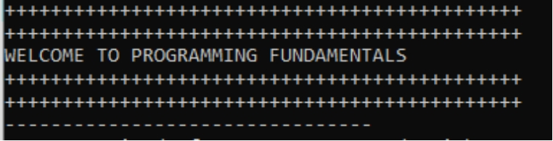

#include<iostream>

Using namespace std;

Int main(){

cout<<”+++++++++++++++++++++++++++++++++++++++++++++++++++++++++++”<<endi;

cout<<”+++++++++++++++++++++++++++++++++++++++++++++++++++++++++++”<<endl;

cout<<”WELCOME TO PROGRAMMING FUNDAMENTALS”<<endl;

cout<<”+++++++++++++++++++++++++++++++++++++++++++++++++++++++++++”<<endl;

cout<<”+++++++++++++++++++++++++++++++++++++++++++++++++++++++++++”<<endl;

cou<<”--------------------------------------------------------------------------“;

}

return 0;

**Write a program that has following variables: Name, SAP id, semester and course. Store your values in these variables and then display them on the screen.**

#include<iostream>

Using namespace std;

Int main(){

string name = Tehreem ijaz;

int SapId = 62688;

int semester = 1;

string course = BS(CS-1)

cout<<name;

cout<<Sapid;

cout<<semester;

cout<<course;

return 0;

}

**Run Dev C++and create a new project and print the numbers in backward order from 10 to 1.**

1. **Without using endl**
2. **With use of endl**

a)

#include<iostream>

Using namespace std;

Int main(){

cout<<”10”<<endl;

cout<<”9”<<endl;

cout<<”8”<<endl;

cout<<”7”<<endl;

cout<<”6”<<endl;

cout<<”5”<<endl;

cout<<”4”<<endl;

cout<<”3”<<endl;

cout<<”2”<<endl;

cout<<”1”<<endl;

return 0;

}

b)

#include<iostream>

Using namespace std;

Int main(){

cout<<”10”;

cout<<”9”;

cout<<”8”;

cout<<”7”;

cout<<”6”;

cout<<”5”;

cout<<”4”;

cout<<”3”;

cout<<”2”;

cout<<”1”;

return 0;

}